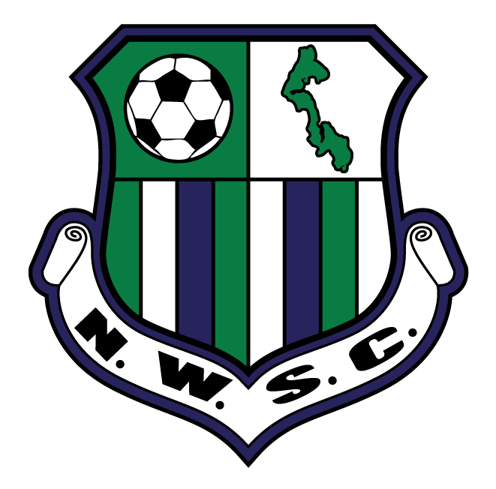
Rock On! 3v3 Soccer Tournament
May 27 & 28, 2017

$130/Team (Youth Division)

Click inside the colored box to type your answer. PLEASE COMPLETE ALL BOXES.
Print to mail, or save to your computer to email as an attachment.
Team Name: |  |  |  |  |  |  |  |  | Division (U8-U18):  (2016-2017 season) |  | U- |  |  |  | Boys |  |  |  |  | Girls |  |  |  |  | Level of Play:  (Rec, Select, Premier)
Club: |  |  |  |  |  |  |  |  |  |  | Association:
Team Contact: |  |  |  |  |  |  |  |  |  | Home Phone: |  |  |  |  |  |  |  |  |  |  |  |  | Cell Phone:
Email Address (This is how we will contact you) :
Mailing Address: |  |  |  |  |  |  |  |  |  |  |  | City/State/Zip:
Coach: |  |  |  |  |  |  | Email: |  |  |  |  |  |  |  |  |  |  |  | Phone(s):
(Type) Signature: |  |  |  |  |  |  |  |  |  |  |  |  |  |  |  | Date:
By my signature above, I, as Team Representative, do hereby assure the Rock On! 3v3 Soccer Tournament and North Whidbey Soccer Club that I have shared the Rock On! Medical Release and Liability Waiver with all of my players' parents, and all have agreed to its content. MEDICAL RELEASE AND LIABILITY WAIVER: I understand that soccer is a strenuous and potentially dangerous sport. I do hereby authorize the Tournament Representatives to act as Agents for my child and to consent to emergency medical, surgical, or dental examinations, treatments, etc. In addition, I hereby release and discharge Rock On!, North Whidbey Soccer Club, and any sponsoring organizations from any and all claims for personal injuries. I agree that pictures may be taken and used for future promotional purposes.
Credit Card Number:  (Visa, MasterCard, American Express, Discover) |  |  |  |  |  |  |  |  |  |  |  |  | Expiration Date: |  |  |  |  |  |  |  |  | CVV: |  |  |  |  | Billing Zip:

Players  (May include players from different organizations) | First Name | Last Name | Date  of  Birth | Shirt  Size  (YM, YL, AS, AM, AL, AXL) | Jersey #  (on shirt player will be wearing during tournament play) | Current Soccer Club (or "none") | ONLY players who have not played with a club team this season (9/2016 - 5/2017) need mandatory field insurance coverage. Those players need to pay an additional $3 each, complete this column and a Medical Release Form, and provide a copy of their birth certificate with this registration.
PLAYER 1 |  |  |  |  |  |  | Address:  Phone:
PLAYER 2 |  |  |  |  |  |  | Address:  Phone:
PLAYER 3 |  |  |  |  |  |  | Address:  Phone:
PLAYER 4 |  |  |  |  |  |  | Address:  Phone:
PLAYER 5 |  |  |  |  |  |  | Address:  Phone:
PLAYER 6  (U8-U10 only) |  |  |  |  |  |  | Address:  Phone:

Required: 1) Registrar-signed ROSTER from club or association which reflects concussion compliance for all participants (unless NWSC fall 2016 or spring 2017 player)
2) If other than Washington Youth Soccer (WYS), a copy of PROOF OF INSURANCE through your USSF organization

Register by MAIL:  Send completed form, along with payment ($130 credit card payment or check made out to NWSC), and all required paperwork to: Rock On! 3v3/NWSC  PO Box 2896 * Oak Harbor, WA 98277 | Register by EMAIL:  From your Team Contact email, send completed form and all required paperwork as attachments to: riverpowers@yahoo.com.  An invoice will be emailed to you.
Registration is not complete until we have received all required paperwork and payments.

REGISTRATION DEADLINE: Monday, May 15, 2017
NO DOGS ALLOWED on Tournament grounds

2017 ROCK ON! AGE GROUPS |  |  |  | Please help us by answering a few questions
AGE GROUP | BORN IN… | AGE GROUP | BORN IN… | How did you hear about the tournament? |  | How many will be in your party?
U8 | 2009 or later | U14 | 2003 | Played before |  | Soccer players
U9 | 2008 | U15 | 2002 | Flyer/Poster |  | Supporters
U10 | 2007 | U16 | 2001 | Facebook |  | How many nights in Oak Harbor?
U11 | 2006 | U17 | 2000 | Instagram |  | Staying in a hotel/bed & breakfast
U12 | 2005 | U18 | 1999 | Word of mouth |  | Camping
U13 | 2004 |  |  | Club or State website |  | Staying with friends/family

