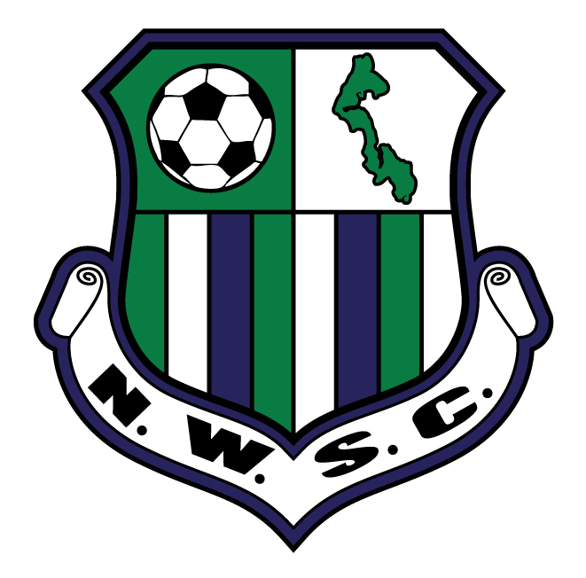
Rock On! 3v3 Soccer Tournament
May 27 & 28, 2017

$165/Team (Adult Division)

Click inside the colored box to type your answer. PLEASE COMPLETE ALL BOXES.
Print to mail, or save to your computer to email as an attachment.

Team Name: |  |  |  |  |  | Division (U19-O50):  (2016-2017 season) |  | U-  O- |  |  |  | Men |  |  |  | Women |  |  |  | Level of Play:  (Rec, Competitive)
Team Contact: |  |  |  |  |  |  | Home Phone: |  |  |  |  |  |  |  |  |  |  |  | Cell Phone:
Email Address (This is how we will contact you) :
Mailing Address: |  |  |  |  |  |  |  |  | City/State/Zip:
(Type) Signature: |  |  |  |  |  |  |  |  |  |  |  |  | Date:
By my signature above, I, as Team Representative, do hereby assure the Rock On! 3v3 Soccer Tournament and North Whidbey Soccer Club that each player on this team’s roster agrees to abide by the Rock On! 3v3 tournament rules, and that each player can produce proof of age should it be requested at any time by tournament organizers. I assure the Rock On! 3v3 Soccer Tournament and North Whidbey Soccer Club that I have shared the following Rock On! Medical Release and Liability Waiver with all of my players, and all have agreed to its content. In addition, I testify that I, as the Team Representative, will have emergency contact information for each player on the roster on hand in case it is needed. I agree, on behalf of each player on the team, that pictures may be taken and used for future promotional purposes.
ROCK ON! MEDICAL RELEASE AND LIABILITY WAIVER: I understand that soccer is a strenuous and potentially dangerous sport. I do hereby authorize my Team Contact or Tournament Representatives to act as Agents for me and to consent to emergency medical, surgical, or dental examinations and/or treatments, etc. I recognize concussion symptoms and understand the potential danger of continuing to play with a concussion. I do hereby release and discharge Rock On! and North Whidbey Soccer Club and any of their representatives, as well as any sponsoring organizations from any and all claims for personal injuries.
Credit Card Number:  (Visa, MasterCard, American Express, Discover) |  |  |  |  |  |  |  |  |  | Expiration Date: |  |  |  |  |  |  |  | CVV: |  |  |  | Billing Zip:

Players | First Name | Last Name | Date of  Birth | Shirt Size  (AS, AM, AL, AXL) | Jersey #  (on shirt wearing during tournament play)
PLAYER 1
PLAYER 2
PLAYER 3
PLAYER 4
PLAYER 5

Register by MAIL:  Send completed form, along with payment ($165 credit card payment or check made out to NWSC) to:  Rock On! 3v3/NWSC * PO Box 2896 * Oak Harbor, WA 98277 | Register by EMAIL:  From your Team Contact email, send completed form to: riverpowers@yahoo.com.  An invoice will be emailed to you.

Registration is not complete until payment has been received.
Proof of age for all players must be available upon request.

REGISTRATION DEADLINE: Monday, May 15, 2017
NO DOGS ALLOWED on Tournament grounds

2017 ROCK ON! AGE GROUPS |  |  | Please help us by answering a few questions
AGE GROUP | BORN IN… | *Adult teams play to the YOUNGEST player | How did you hear about the tournament? |  | How many will be in your party?
U19/20 | 1996-1997 |  | Played before |  | Soccer players
O20 | 1986-1997 |  | Flyer/Poster |  | Supporters
O30 | 1976-1987 |  | Facebook |  | How many nights in Oak Harbor?
O40 | 1966-1977 |  | Instagram |  | Staying in a hotel/bed & breakfast
O50 | 1967 or earlier |  | Word of mouth |  | Camping
 |  |  | Club or State website |  | Staying with friends/family

